Solution-Focused Scaling Questions
© 2009, Coert Visser

Steve De Shazer, an American therapist and co-developer of the solution-focused approach, once, in the nineteen-seventies, talked with a client who came for his second session. He asked the client what was better now. The client had spontaneously replied: “I’ve almost reached 10 already!” De Shazer began to play with the idea of using numbers to describe one’s situation. This started the development of the scaling question used in solution-focused therapy (Malinen, 2001). Today, scaling questions have developed into the most well known and most frequently used solution-focused techniques. Scaling questions are relatively easy to use and extremely versatile. Nowadays, many therapists, coaches and managers use them. Even many people who know little about the solution-focused approach know the scaling question.
1. Basic steps when using the scaling question
Asking the scaling question is usually done by following a few basic steps. These basic steps consist of a series of questions which are posed in a curious and encouraging way. Below, these basic steps are explained.
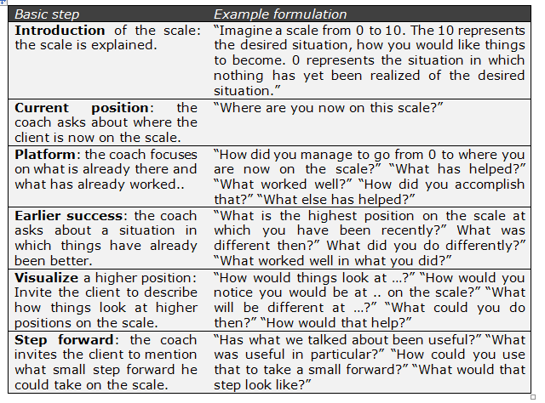
The following picture (Visser, 2009) visualizes all of these steps:
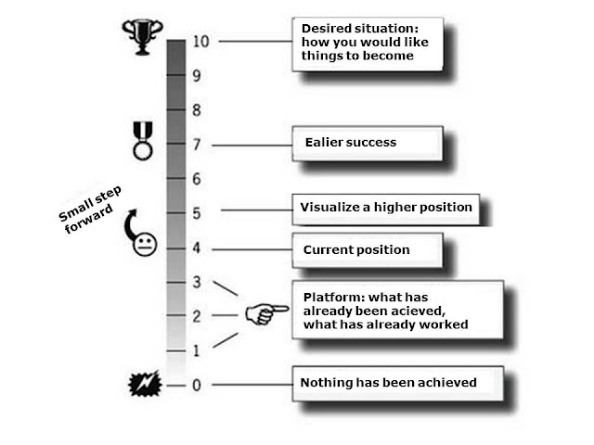

2. Different types of scales
There are many ways of using scaling questions. Below are the most frequent uses of the scaling question.
1. The success scale: this is the most well-known application of the scale. On this scale 10 is the desired situation and 0 is the situation in which nothing has been accomplished yet. The success to which this scale refers can be about anything that you may find relevant such as communicating more effectively, dealing more effective with problems, producing more efficiently, working more client oriented, etcetera.
2. The motivation scale: this scale is used to discuss and strengthen the motivation the client's motivation. On this scale, the 10 may be something like: “I am prepared to do a lot to achieve the goal", and 0 may be: “I am not willing to do anything for it". It may seem a bit paradoxical but by going through the basis steps of the scaling question clients often get more grip on their own motivation. They learn to regulate their own motivation and become capable of motivating themselves. When their motivation would be low they could do things that had helped them in the past to become more motivated.
3. The confidence scale: this scale is used to discuss and strengthen the client's confidence of being able to reach the desired situation. A 10 may be: “I have much confidence of being able to accomplish this” and a 0 may be: “I have no confidence whatsoever.” Just like with the motivation scale the client learns to regulate his own confidence. This can have a strong stimulating effect. When a client has little confidence that he will be able to accomplish something it makes no sense for him to take action. Once his confidence grows the threshold is lowered to take action.
4. The independence scale: an important principle in solution-focused work is that we want to keep clients from becoming dependent on coaches. The independence scale can help to establish that. This scale is used to discuss and strengthen the clients self sufficiency. A 10 may be: “I know how I can proceed with this and I don't need help anymore” and a 0 may be: “I don't know how to proceed with this and I need help." The independence scale is often used in situation in which the client has some kind of decision problem. The advantage of this scale is that it helps to keep coachings and therapies from taking longer than strictly necessary. While the problem may not be completely solved this does not have to mean that the professional help has to continue. Often, the client is able to continue independently.
3. Using scales in groups
Scaling questions are not only useful in one-on-one conversation but also in groups. Below are two examples of the use of scales in groups.
1. Group scaling question: Below is a fragment from a team session between a solution-focused team coach (TC) and a team. The coach is asked to coach the team members (TM) a few times in order to help improve team cooperation. He uses the scaling question.
  - TC: I would like to ask you whether your team, as far as you're concerned, is already exactly like you want it to be?
  - All: (Laughter) No!
  - TC: (Smiling) No problem! It would be the very first time for me to be in a team where everything was exactly like everyone wanted. Okay, I would like to explore where the team already is. Imagine a scale from 0 to 10 with 10 being the situation in which things will have become like you would like them and 0 being the situation in which nothing is going like you want it to go yet. Would you write down on the little post it notes where you think the team is now on that scale?
The team members write down their score on the scale and pass them on to the team coach. The team coach asks them to take a few minutes and talk with the person sitting next to them about a recent situation in the team that went well. In the meantime the team coach calculates the average score. After a few minutes the team coach starts talking again.
  - TC: Thanks for your scores. I have calculated that the current score of the team is a 6. So things are not quite like you want them to be but you seem to be well on your way to that situation. How did you manage to reach that 6?
  - TM 1: …. It is not that we don't work for it, you know? I mean you only have to look at they way we are all sitting here and seriously participating in this process.
  - TC: Indeed, I notice that. What else has helped to reach that 6?
  - TM 2: We have all reached a point at which we want to leave the problems of the past behind us and to start looking forward, you know?
  - TC: that sound good, what else?
  - TM 3: When it really comes down to it we take care of doing a good job as a team.
The team coach goes on asking for more examples for about ten minutes and then asks a different kind of question.
  - TC: The team is now at a 6 .. Imagine that the next time we meet the team will be at a 7. What would be different in the team then?
  - TM 2: We would listen better to one another. When someone says something in the team meeting he can really explain what he wants to say and he is taken seriously.
  - TC: Fine, and what else?
  - TM 4: We would be on time for the meeting. All of us would be on time.
  - TC: I can imagine that would be good thing. What else?
  - TM 1: We support each other better when we see that a colleague is really busy. We help each other out better.
The conversation continues. For an hour the coach asks all kinds of things using the scale. For example, he asks for examples of situations in which the team has already been a bit higher on the scale. Near the end of the session, he invites each team member to think for them selves about what they can do to help the team move one small step forward on the scale. When the session is over the atmosphere is positive. The team members have found the session useful and pleasant.
2. Scale walking: This is an application of the scale which you can use in small and large groups. You ask the members of the group to imagine that one side of the room represents 0 on the scale and the other side 10. Then you ask them to think what their current position is and you tell them that this current position is represented by the letter N. Then, you invite them to come and stand on an imaginary line (somewhere halfway on the scale) and you tell them to imagine that this position is N, their current position. Then, you ask them to think about how they have been able to go from 0 to N. Next, you ask them to turn around and face the other side of the room, where 10 is. You ask them to think about what they see as they watch that part of the scale. Then, you invite them to come and stand on the 10 position and to visualize for themselves what will be different here and what they will do differently themselves. After that, the group members are asked to come and stand at their current position again and to think about which small step forward they could take. You ask them to physically take a step as soon as they know which step they will take.
Scale walking has some attractive features when working with a group. The exercise is often very lively and usually creates lots of energy and enthusiasm. Also, the exercise is very flexible. You can use it in many different types of situations. For instance, you can use it when members have individual goals. But you can also use it when there is a common them so that the scale represents a group goal (for instance 'improve customer satisfaction'). In this case, using the scale leads to a situation in which all members think about steps forward to achieving that goal.
4. Several tips for using scaling questions
4.1 What to do when the client is now at a 0?
When using scales, clients will usually say that their current position on the scale is somewhere between 0 and 10. But every now and then it happens that clients say they are now at a 0. In this case it is obvious that you can not ask them how they have been able to go from 0 to their current position because their current position is a 0. Well, what can you do in such a situation? 0 is. When a client says he is now at 0 he often wants you to understand how serious his situation is. The solution-focused coach shows understanding and acknowledges what the client says. Then, the coping question can be asked, for example like this: “How do you manage to go on in these tough circumstances?" The coping question often helps people to find new energy to cope with their difficult situation. Often, this also helps to create a new angle to continue the conversation. For instance, when the client says: “I manage to go on because I don't want to disappoint my children, the coach can build on that by asking: "How would you know your children would not have to be disappointed?”
4.2 The importance of effective scale anchors
When using scales it is important to define your scale anchors, in particular the 10-position, carefully. Scales usually work best when the 10-position is defined not in too idealistic terms (the ideal future) but rather in more realistic terms (the desired situation, the situation you would be satisfied with). Being idealistic in your definition of the 10-position has two disadvantages. The first is that you can be sure that an ideal situation will never be achieved. Problem free, ideal situations don't happen. There are always problems, challenges, and tensions, they belong to life. A second disadvantage of the 10 as ideal is that it will make the client scale the current situation lower. When the 10 represents an ideal situation the client may score the current situation as a 2, while he may score a 4 or a 5 when the 10 would be defined as the situation that would be good enough. A too idealistic 10 can demotivate.
Another aspect of choosing effective scale anchors is shown in the following example. Imagine a client wants to loose 50 pounds of weight and is helped by a solution-focused coach. When the coach would define the 10 position as the situation in which the client would have achieved the goal and would have lost the 50 pounds that could demotivate. The reason is that you could be quite sure that it would be impossible to get at the 10-position anytime soon. It would be wiser to use a different way of defining 10, for instance like this: the situation in which you would be satisfied about your eating behaviors. By defining the scale like this, it is possible for the client to move quickly to the 10-position on the scale which can be very motivating. The actual weight loss can of course be monitored on a different scale, the one in your bathroom.
4.3 Playing with scales
Often it is possible and necessary to be inventive and playful when using scales if only because clients often do that too. In a team building session, a coach once used the scale walking technique. The exercise went fine and the coach noticed how the energy in the group grew while they proceeded. At a certain point, the coach invited the members to think about which step forward they could take on the scale. He asked them to physically take a step when they knew what step it was. The team members thought for a moment and then, one after the other, took a step forward. One person thought longer than the others and eventually took a step backward instead of forward. The coach was surprised for a moment and wondered if the participant was joking. But then, the coach became curious and asked: “Hey, that is interesting... You're taking a step backward... Would you care to explain that?" The participant responded with a serious look on his face: “I am very perfectionist and by taking a step backward I want to symbolize that I am going to let things loose a bit more.” The coach responded: “Sounds good!”
5. Using scales with multiple goals
Sometimes people wonder about whether scaling questions aren't too simple to be used in complex real life situations. In complex real life situations there is often a situation when there multiple goals instead of only on goal (like improving commercial skills). Moreover, often these goals are interrelated in one way or the other, or they maybe be competing with each other. An example may be the case of a company in which one group advocated the use of proactive environmental practices. For instance, they objected to the abundant use of plastic covers around certain products. Another group in this company objected to this groups saying that the focus of the company should be achieving financial goals. The tension between these two groups grew to rather unpleasant proportions when members of both groups started accusing each other of all kinds of bad intentions and behaviors. A solution-focused coach was hired to solve this matter. To everyone's surprise, the parties were again on speaking terms within one session and fully cooperating with in two brief sessions. What happened?
The first thing the coach did was to listen carefully to both parties trying to understand their goals. After that, the coach suggested a framework in which the relationship between both goals was visualized (see below).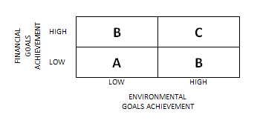
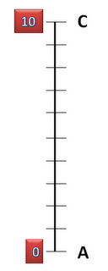

Then, he asked them what they considered the most desired position in this matrix. They immediately agreed that C was the preferred place to be. Then, the solution-focused coach drew a scale which looked like scale on the picture on the right. Next, he asked the group whether this scale represented their goals adequately, to which all of them could agree. Then he asked then to consider this scale and discuss with each other where they saw themselves now on this scale. Then he used all the familiar parts of the scaling questions. A bit to their own surprise the group members started to agree more and more and discovered that there were some very interesting opportunities to improve both environmental and financial performance at once. For instance, they indeed started to use less plastic covers which was not only desirable from an environmental standpoint but also lowered direct costs and production time. One member called these 'low hanging fruits'. What is interesting is that, in the second session, the group became more united. The financial people showed increasing enthusiasm for the environmental goal and vice versa.

